**Name:** José Rodrigo Reséndiz Díaz.

**Birthdate:** 22 de junio de 1996

**Edad:** 20 años

**Curp:** REDR960622HMNSZD06

**Address:** Calle Olivos, # 94, Colonia Lomas del Panteón, c.p 61250, Ciudad Maravatio Michoacán de Ocampo.

**Phone:** 4471112641

**Email:** joserodrigoresendizdiaz@gmail.com

**Civil status:** Single

**Nationality:** Mexicana

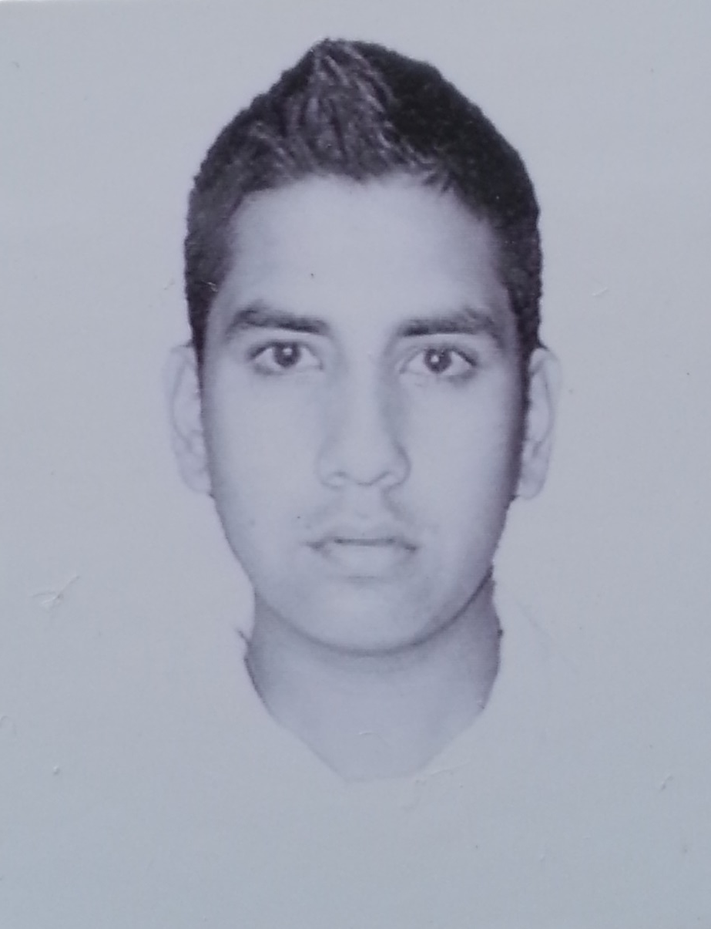

**ACADEMIC FORMATION**

Universidad Tecnológica de León, Unidad Académica del Sureste.

**Career:** Ingeniería en Tecnologías de Información y Comunicación.

**Year:** September 2016 y **Currently:** Studying.

**Address:** Carretera Acámbaro-Tarandacuao, km 8, Colonia San Miguel del Puerto.

**Phone:** 15-50-600

Universidad Tecnológica de León, Unidad Académica del Sureste.

**Career:** Técnico Superior Universitario en Tecnologías de Información y Comunicación.

**Tittle:** In the process.

**Average:** 9.1

**Year:** September 2014 – August 2016.

**Address:** Carretera Acámbaro-Tarandacuao, km 8, Colonia San Miguel del Puerto.

**Phone:** 15-50-600

**PERSONAL OBJECTIVE**

Be a person committed to personal and professional growth.

**PROFESSIONAL OBJECT IVE**

To consolidate myself professionally to be able to exercise my skills and knowledge to be able to grow in the personal and professional spheres.

**LANGUAGES**

Language Spanish Castilian mother, English basic level.

**WORK EXPERIENCE**

**Company name:** Aceros Comerciales y Estructurales Monterrey

**Job:** Programmer.

**Period:** May - August 2016.

**Main activities:** Development of an e-commerce website in a CMS to give the company more advertising tools so that it was better known in the municipality could also sell its products through the implementation of an online sales module.

**PERSONAL REFERENCES**

**Contact name:** Francisco Regalado Caballero **Phone:** 4171028696

**Relationship:** Friend **Email:** Franciscoregalado80@gmail.com

**Contact name:** Eduardo Martínez Fosado **Phone:** 4471138976

**Relationship:** Friend **Email:** Eduardofozado@gmail.com

**COMPUTERS SKILLS**

Programming language:

* PHP (90%), Object-oriented java (90%).

System software:

* Operating systems (Windows (95%), Linux (85%)).

Programming software:

* Netbeans (90%), StarUML (90%), Sublime Text 2 (90%).

Application Software:

* Office (Microsoft Word (95%), Power Point (95%), Excel (95%), Publisher (90%), Visio (90%), Project (95%)).
* Audio editors (Sound Forge (90%), Audacity (90%)).
* Image editors (Macromedia Fireworks 8 (90%), CorelDRAW X7 (95%), Photoshop (95%)).
* Video editors (Camtasia Studio8 (95%), Adobe Premiere (95%)).
* Data Base Management System (MySQL (90%), Microsoft SQL Server (85%)).
* Others programs (Adobe Director (90%), Blender (90%), Local Servers as XAMPP (95%) and WAMP (95%), FileZilla (95%), Mockups (85%), Workbench (95%), WordPress (95%), Documentation knowledge of starUML projects (95%), among others).

**TIME AVAILABILITY**

I count on the availability of time and travel.

**OTHER DATA OF INTEREST**

During my educational training I have acquired knowledge related to multimedia and e-commerce.